Smart Rivers 2019 Conference
/ September 30 - October 3, 2019
Cité Internationale / Centre de Congrès
Lyon FRANCE /

Ref. author:
Sébastien Legrand - CNR
2, rue André Bonin, 69316 Lyon cedex 04, France
s.legrand@cnr.tm.fr

Co-authors:
Blaise-Léandre Tondo – CICOS
Building Kilou, 24, avenue Wagenia, Kinshasa-Gombe, Rép. Dém. Du Congo
blaisetondo@yahoo.fr

Christophe Brachet – International Office for Water
21, rue de Madrid, 75008 Paris, France
c.brachet@oieau.fr

Benjamin Graff – CNR
2, rue André Bonin, 69316 Lyon cedex 04, France
b.graff@cnr.tm.fr

Keywords:
Inland navigation, Congo River, Spatial altimetry

Title:
Spatial altimetry to improve inland navigation in the Congo basin

Full Paper:
You are expected to upload a short paper draft (1500 words max or 3 pages) before May 15th.

Introduction
CICOS (International Commission for Congo-Oubangui-Sangha Basin) was created in 1999 and includes 6 countries of Central Africa (Republic of Angola, Republic of Gabon, Republic of Cameroon, Republic of Congo, Democratic Republic of Congo and Central African Republic). Its mandate includes inland navigation and integrated water resources management.
With more than 17,000 km of waterways, inland navigation is a major mode of transport for Congo River riparian countries. But obstacles, such as a poor regulatory framework or obsolete infrastructures, prevent navigation from contributing to the regional economic development.
In the same way, hydrological information is lacking in CICOS Member Countries, due to its cost and degradation of historical monitoring systems. This lack of information limits knowledge of water resources, although this knowledge is necessary for any navigation improvement project.
In recent years, a new technology has emerged in the field of hydrology, called spatial altimetry. This technology consists in river elevation measurements by satellite at different points of the river. These points are called virtual stations (see Fig 1).
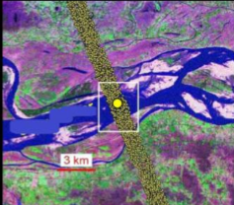
Fig 1. Virtual Station.
Aware of these measurement difficulties and the progress of this new technology, CICOS signed in 2017 an agreement with seven French entities to develop services that would incorporate spatial altimetry as an input data. These entities are members of the “Space hydrology working group” contributing to the development of satellite data use, especially spatial altimetry.
In the frame of the agreement, CICOS asked CNR to improve navigability prediction on the Sangha River. This study was funded by the French Development Agency (AFD). International Office for Water (IOWater) is providing technical assistance to CICOS for the project.
In this paper, we will present the data and the methodology used. Then we will present and discuss the results and the contribution of spatial altimetry to navigation in the Congo basin.

1. Background

1.1 CNR (Compagnie Nationale du Rhône)
Founded in 1933, Compagnie Nationale du Rhône (CNR) received from the French Government in 1934 the concession of the Rhône River to develop and operate the river according to 3 core missions: hydropower generation, inland navigation and irrigation.
This development has led to the construction of 19 run-of-river projects all along the Rhône River in France. They include 14 wide gauge locks remotely operated from the Navigation Management Centre (24 hours a day, 365 days a year), pleasure locks, as well as 18 multimodal sites equipped with structures and/or river tools for logistical connections between the river, rail and road.
Designer and operator of these 19 run-of-river projects with 85 years of experience, CNR also supports other stakeholders in the fields of river engineering to sustainably develop the basins and rivers under their responsibilities.

1.2 The “Space hydrology” working group
The French Development Agency (AFD), BRL ingénierie, CLS, CNES (French Space Agency), IRD, Irstea, International Office for Water (OIEau) and CNR are members of the French space hydrology working group.
The purpose of the working group is:
- to develop operational applications using satellite data as input, and especially spatial altimetry,
- to prepare France-US SWOT program (Surface Water Ocean Topography), a satellite that will be launched in 2021. SWOT will afford continuous coverage of a 120-kilometre swath. Thanks to this wide ground track, SWOT will be able to acquire measurements of surface water height in more than 100-metre-wide rivers and to quantify slopes.
The project discussed in the paper is also based on the contributions of each member of Space hydrology working group to the knowledge of the Congo basin water resources.

2 Inland navigation on the Sangha River

The Sangha River is a tributary on the right bank of the Congo River, which drains a watershed of 213,000 km², i.e. about 6% of the total Congo River watershed. The Sangha River basin is shared between Cameroon, Central African Republic and the Republic of Congo.
The main economic issue for navigation on the Sangha is transport, especially transportation of wood between Brazzaville and Ouesso, the main port in the Sangha basin. Though navigation is economically important, low water levels prevent navigation during several months every year.
The maintenance of the navigable channel on the Sangha River is carried out by the Joint Service for the Maintenance of Waterways of the Economic Interest Group of the Republic of Congo and the Central African Republic (GIE-SCEVN). GIE-SCEVN, based in Brazzaville in Republic of Congo, is involved in the following areas of activity: marking of the navigable channel, dredging, hydrographic studies, etc.
Ouesso staff gauge water level is read daily. This staff gauge is an indicator of the navigability of the Sangha River: when the water level is below 70 cm in Ouesso, navigation must be stopped.
Navigation improvement on the Sangha river and its tributaries is part of CICOS strategic action plan for inland navigation, covering the period 2016-2020.

3. Forecasting water level: data and method

3.1Project objective
The objective of the project presented in this paper is to develop a model to forecast water levels at Ouesso, to anticipate navigation stops or adapt ship loadings. Furthermore, CICOS specifically requested the study of spatial altimetry added-value.

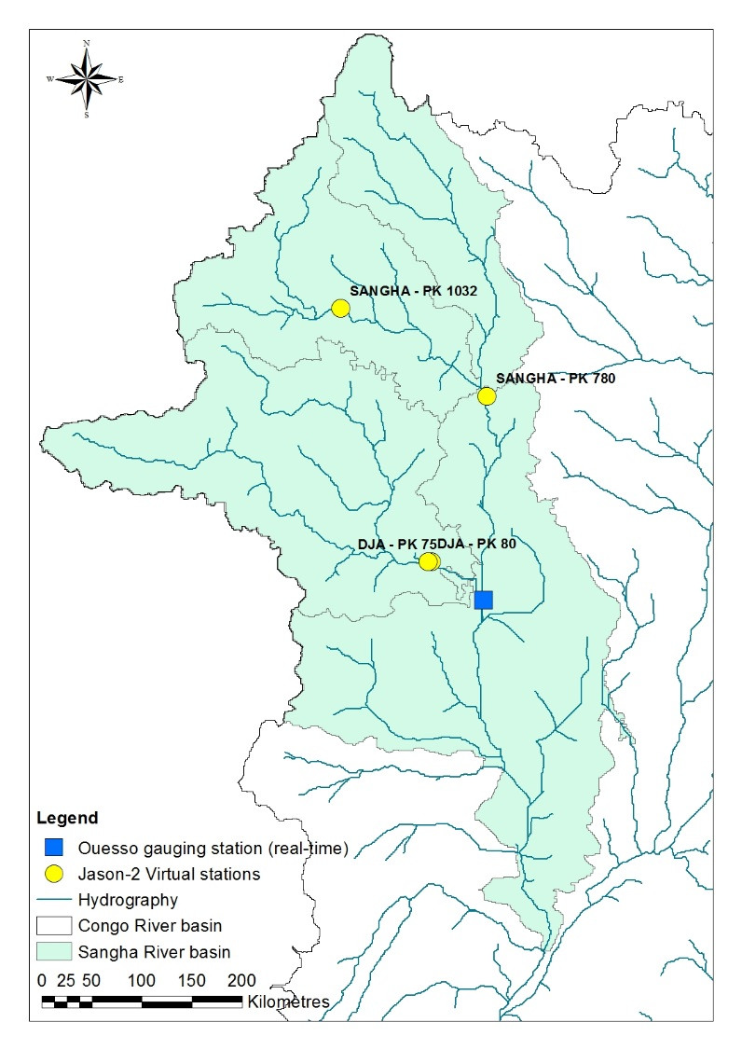
3.2 Data
Data available to forecast Ouesso water levels include hydrometric data at gauging stations, altitudes at virtual stations and Global Precipitation Climatology Project (GPCP) precipitations. The study period is 2002-2012.
Hydrometric data are made of observed or reconstituted water levels and discharge at Ouesso and at other stations on the Sangha basin. But only Ouesso data are read and transmitted daily by the GIE-SCEVN.
Four virtual stations are used in this study to calibrate the model (see Fig 2). These virtual stations are measured by the Jason-2 satellite (now deorbited). Measurements are performed with a return period of ten days or more.
The operational use of the model requires the use of the same virtual stations, measured by the Jason-3 satellite, currently in flight.

3.3 Methodology
Models are general linear model including the latest water levels available at Ouesso, the latest rainfall and water level at virtual stations, if available at the time of the forecast. Forecasts include lead times from Day+1 to Day+15. The quality of the model is quantified through the adjusted R-square.
Spatial altimetry’s added-value is quantified by comparing adjusted R-squares with and without spatial altimetry as explanatory variables. Both the default model and the model integrating spatial altimetry are calibrated on the same subset of data, which depends on the data availability at each virtual station.
Fig 2. Map of the Sangha basin.

3.4 Results
The default model is based only on water levels and precipitations. As Ouesso station drains a large catchment area, water level variations are slow. Consequently, the default model has good results.
Results show that for some lead times and depending on which virtual stations are available, the best model using spatial altimetry got a higher adjusted R-square (see example for virtual station PK80 only, on Fig 3).

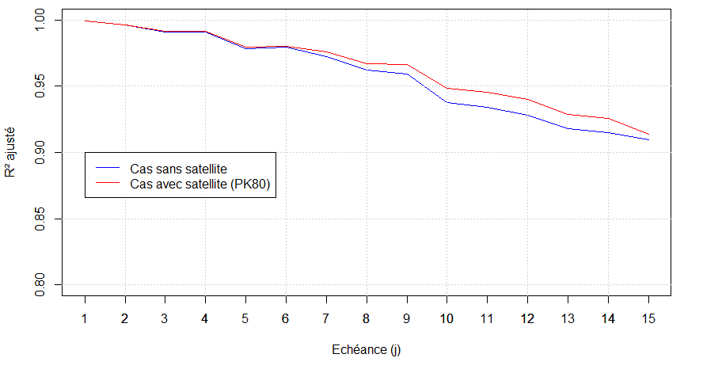
Without satellite
With satellite (PK80)
Lead times (day)
Adjusted R-square
Fig 3. Example of result: adjusted R² with and without satellite measurements.

4 Discussions

4.1 Discussions on results
Results show that the adjusted R² is higher in some cases with data from virtual stations as input. This validate the potential added-value of space hydrology for water level forecasting. But these results depend on the low number of calibration data with spatial altimetry.

4.2 Discussions on improving the forecasting model thanks to spatial altimetry data
Ouesso hydrometric station is the main input of the model. The quality of its data is a major issue for model improvement. It requires in-situ measurements such as discharge measurements and control of historical data quality.
Daily upstream hydrological information would improve Ouesso forecasts using propagation. Unlike spatial altimetry data, gauging stations can be available daily. But none of the historical stations identified on the Sangha River basin actually is.
To improve information for navigation, this model could be combined with a hydraulic model of the Sangha River. It could help identify river stretches with low fairway depth and deliver more precise low water warnings. Such a hydraulic model would also require bathymetric measurements.
It is important to note that hydropower Chollet dam will be developed on the Dja River in the coming years. This dam will impact the hydrology of the catchment. It is recommended to collect data of dam operations to improve hydrological knowledge and forecasting on the Sangha River.

5 Concluding remarks: Spatial altimetry, an opportunity for CICOS Member Countries
Spatial altimetry is already an interesting complement to conventional hydrology. SWOT satellite, that will be launched in 2021, is likely to add value to hydrology, thanks to its spatial coverage, accurate information on water surface altitude and slope as well as flow estimates.
Another advantage of spatial altimetry, in a context of limited financial resources of CICOS Member Countries to ensure the sustainable operation of gauging stations, is that virtual stations do not require operational expenditures for the material.
Nevertheless, it is important that CICOS Member Countries allocate a budget to maintain models and operational applications using space altimetry as input data. It is also mandatory to proceed to regular discharge measurements or bathymetric surveys to ensure the reliability of model output or to maintain and adapt Information Technology tools.

